Structure AND Lameness
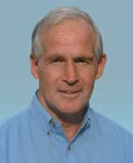

by Alex Ashwood
BRAHMAN NEWS MARCH 2011 Issue #170
Today's beef producers face many different management challenges including increased herd sizes and larger cattle which impact on herd health particularly leg and feet structure and lameness.
Lameness has a positive genetic correlation to reduced performance
Foot and leg problems can be a major herd problem due to reduced performance (weight gain and reproduction) resulting in lower productivity and increased economic losses.
Figure 1 illustrates the four main groups of factors which can directly lead to lameness or which interact and subsequently intensify minor stimuli sufficiently to cause subacute or acute lameness.
FIGURE 1: PREDISPOSING CAUSES OF LAMENESS
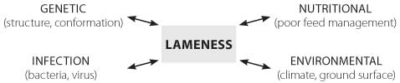
Nutrition, environment, disease and genetic influences combine with management factors to predispose stock to lameness.
Foot and leg conformation have less predictable heritability (0.8-0.16) than the measurable performance traits (eg mature weight 0.50). Nevertheless, structural traits and problems are heritable and need to be fully considered when purchasing and breeding seed stock.
"Foot problems compounded by poor leg structure cause lameness"
In order to fully understand lameness it is advantageous to become familiar with the anatomy of the foot and the basic structure of the legs, shoulder and hindquarter.

Foot Structure
The conformation of the foot (Figure 2) should be short and steeply angled, high in the heel and even clawed. The sole should be somewhat concave with the majority of weight placed on the hoof wall.
FIGURE 2: cross section of the foot
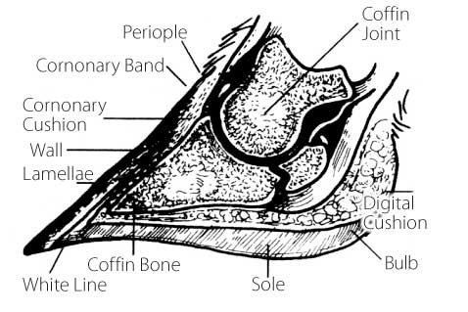
Source : Zinpro®

FIGURE 3: EXAMPLES OF FOOT DEFECTS
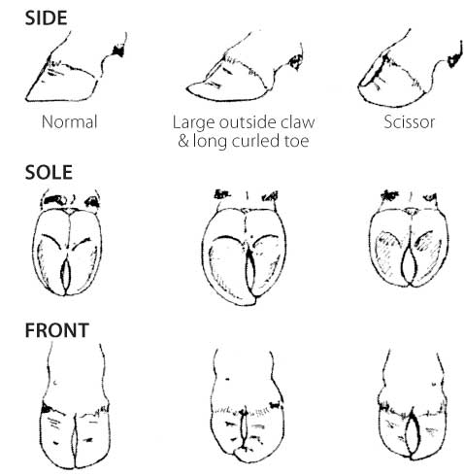
The anatomy of the foot (Figure 2) indicates the complexity of the structure and clearly demonstrates why structural faults and problems lead to foot damage and lameness.
- Coronary Band – is normally soft and shiny and grows at the rate of 5 millimetres per month. This is an area that can be easily penetrated by foreign objects particularly between the toes
- Bulb – is the continuous with the coronary band and is composed of soft rubber horn.
- Wall – is smooth and shiny and consists of a very tough tubular horn
- Coronary Cushion – is a mass of elastic tissue and veins beneath the coronary band. When the animal moves, the cushion pumps blood through the foot and back into the body.
- Lamellae – there are hundreds of tiny ridges in the lower part of the inside wall which are attached by fibres to the coffin bone.
- Periople – is the area where the skin meets the coronary band. It is here that lamitis is often first noticed.
- Corium – sometimes called the 'guide or dermis" produces hoof horn (wall). The health of the corium establishes the quality of the hoof produced. Reduced quality leads to foot damage and lameness. Extreme concussion to the corium due to poor leg structure creates sensitivity, pain and lameness.
- Coffin Bone – sometimes called the pedal bone is suspended within the corium and when damaged or stressed causes severe lameness.
- White Line – is a greyish area where the sole meets the hoof. Its function is to separate sensitive tissue from non sensitive tissue. It is an area that can be easily penetrated by foreign objects, particularly with faulty foot structure
- Digital Cushion – is situated inside the bulb and functions as an elastic shock absorber. It also forces blood back into the limbs as the animal walks.
- Foot defects (eg scissor and corkscrew claws) are genetic (inherited) and overgrown feet is generally a sign of poor leg structure and/or nutritional problems.

Foot Angle and Depth
Studies show that higher claw angles are positively correlated with increased herd life of bulls. The ideal angle is about 45-55 degrees. Deviation from this angle usually indicates poor leg structure (eg sickle or straight hocks and weak pasterns).
Defective feet generally worsen with age and problems are accentuated with poor feed management (eg overfeeding grain and insufficient minerals) and challenging environments (too abrasive or wet).
Heel depth is related to foot angle and deeper heels with sufficient angle reduce the incidence of lameness. Heel depth is also related to the slope of the pastern (Figure 4).
FIGURE 4: FOOT AND PASTERN STRUCTURE
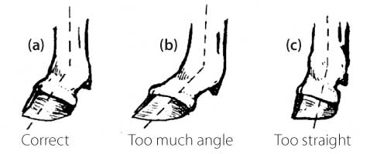
Long slopping claws or short block claws indicate too much or not enough pastern angle and can indicate structural faults of the pastern or the upper limbs (eg shoulder too straight). Incorrect angle of the pastern causes the hoof to wear abnormally which affects the mobility and performance of the animal. Shallow heels can lead to bruising and increase the chances of damage and infection.

Weight Distribution
While standing the weight should be distributed between the front and hind legs.
"Most lameness (85 per cent) involves the hind feet"
A simple calculation will indicate how much weight is carried and clearly demonstrates why the foot can be easily stressed. With a 460 kg heifer, approximately 260 kg rest on the forelegs and 200 kg on the hind limbs (Figure 5). This means a weight of 100 kg per hind leg or 50 kg per claw (Figure 5). Note: this means that substantial pressure is placed on a few square centimetres of the corium under the pedal bone.
With heavier animals (eg bulls) twice as much weight can be transferred to the foot and hooves (eg a mature bull can transfer 200 kg per hind leg and 100 kg per claw). When servicing a cow these weights are increased even further. Subsequently sensitivities in hind legs and feet reduces reproduction.
During locomotion, the centre of gravity ("G") shifts from side to side (Figure 5) and the weight bearing by each hind claw varies with the movement.
FIGURE 5: WEIGHT DISTRIBUTION ON THE FOOT
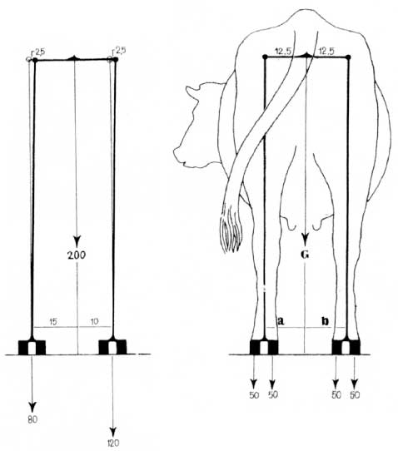
"The majority of hind leg lameness involves the outside claw"
The outside claw of the hind legs bear the burden of the continuously changing weight load during locomotion. This may be the reason that these claws are more often damaged.
The outer hind claw is more heavily stressed which explains why the outside claw is larger than the inside claw and the heel is deeper and the sole thicker. Despite these adaptations the results of poor leg structure leads to an increased incidence of lameness.
The front feet bear weight load changes more evenly but when problems do occur the inside claw is usually the most affected.

Damaged Feet
The foot is protected by the hoof and its outer structures (Figure 2). The hooves are the first line of defence against foreign objects and infection. Foot damage can also be caused by internal factors such as poor feed management and disease (Figure 1).

Leg Structure
Abnormal structure of the hindquarter, shoulders and legs alters weight distribution, leading to stresses, inflammation and impaired function (ie walking and serving ability).
Structurally correct stock have a free moving gait (locomotion) with the hind feet stepping into the front footprints. Over or understepping of the hind feet is an indication of structural leg problems.
"Structural problems increase the incidence of lameness"
- Front End
+ Shoulders
FIGURE 6: FRONT LEG AND SHOULDER STRUCTURE
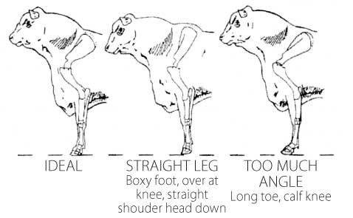
The angle between the shoulder blade/shoulder/elbow should be 90-95o (Figure 6). Angles greater than this (eg straight shoulder) reduce shock absorption causing a short-choppy gait. With straight shoulder bulls the top of the shoulder blade is prominent above the backbone and the stock have high-open shoulder blades instead of smooth shoulders against the ribs.
+ Front Legs
Figure 7 shows that the legs should be straight when viewed from the front.
FIGURE 7: STRUCTURE OF THE FRONT LEGS
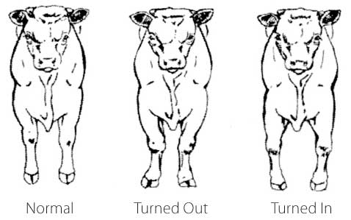
With turned in knees (knock kneed) stock may have overgrown outside claws which contributes to stress and lameness. Turned in knees (bow legged) causes stock to roll their feet and these animals are prone to arthritis.
"Arthritis is caused by poor leg and joint structures"
- The Rear End
+ Rear Legs
The angle between the hip and the hock joint should be 90-95o. Angles greater than this (post legged) reduces walking and mating ability.
FIGURE 8: SIDE VIEW OF FRONT AND HIND STRUCTURE
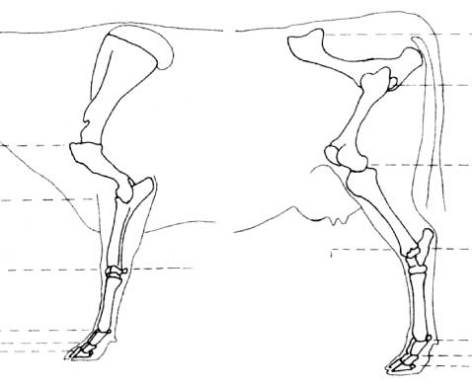
Note: Correct front and hind structure is all about the angles between the joints.
There is a strong relationship between rear leg structure and the soundness of the rear feet.
Figure 9 shows the degree of inward (cow hocked) or outward (bow legged) deviation from the hocks. Normal limbs (a) facilitate straight locomotion with the bigger outer claw carry the greater share of the weight load.
FIGURE 9: REAR VIEW OF HIND LEG STRUCTURE
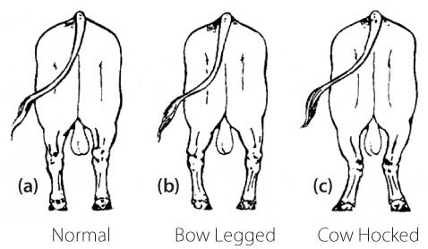
Viewed from the back, the leg should be vertical. Stock with their hooves rotated outwards (cow hocked) can have uneven growth of the outside claw. Stock that are wide at the hocks with their feet turned inwards (bow legged) can suffer increased levels of stress and strain on the ligaments causing lameness and permanent damage.
"A high percentage of bulls are culled due to lost mobility"
Viewed from the side (Figure 10) straight hind legs (post legged) is a serious fault which leads to arthritis in the hocks, hips and joints.
FIGURE 10: SIDE VIEW OF HIND LEG STRUCTURE
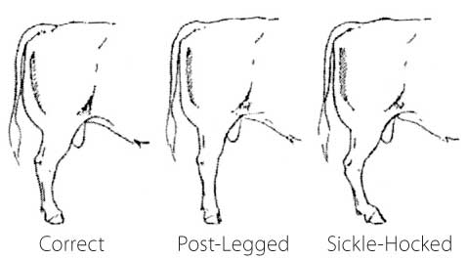
Straight legged bulls are often clumsy servers and can suffer high incidences of damage to the penis. Too much angle through the hocks (sickle hocked) whilst undesirable is not as serious a problem as post leggedness. Sickle hocked bulls are also clumsy servers particularly at the dismount.
Both post leggedness and sickle hocked conditions adversely affect the bulls servicing capacity and lead to an earlier 'breakdown' in the life of the bull.

Nutrition
Feed management will be discussed in a later article titled "Acidiosis and Laminitis". However, incorrect energy and protein balances and mineral/vitamin deficiencies play a clear role in lameness.
All rations should be balanced for calcium, phosphorous for good bone health. Other helpful minerals for foot health include zinc, copper, molybdenum and manganese.
Rations need to include the correct levels of fibre and the fibre should have the right physical form and particle size to increase chewing which produces saliva (buffer) which aids digestion.
Depending on the grain source, the non structural carbohydrates should not exceed 40 per cent of the ration. Feeding incorrectly processed grains with inadequate levels of fibre causes metabolic disorders and lameness.
"Arthritis is accentuated when young bulls are fed high grain rations"
Overfeeding protein can cause the abnormal growth of the hoof. Conversely defective diets produce poor wall growth. Intensively feeding increases body weight subjecting joints, legs and feet to greater weight loads and stresses.

Disease
The most common bacterial cause of lameness is foot rot. Foot rot is characterised by a necrotic lesion in between the claws (interdigital) which may extend into the soft tissues of the foot causing swelling and lameness. If not treated promptly and correctly, foot rot (and other foot diseases) can pose grave consequences for the infected animal.
"Mortalities may be low but mobility and economic loss is high"
Preventative measures include foot bathing (eg copper sulphate, Epsom salts) and treatment with injectable antibiotics as prescribed your veterinarian.
Stock with poor leg/feet structure are more prone to foot injuries and infection.

Environment
The importance of environment should not be overlooked particularly for sale bulls held in small enclosures. Foot lesions vary in type and severity depending on the climate and the abrasiveness of the surfaces the animal walks on.
Hot, dry climates harden the hoof which may increase the resistance to trauma but causes the hoof to be more brittle. On the other hand excessively wet conditions soften the hoof and these conditions favour invasion by bacteria and foreign objects.

Selection Outcomes
Lameness and poor performance due to structural faults is considered a major herd health problem which reduces herd performance. Only reproduction is more important reason for selective culling. Furthermore, lameness and faulty leg/feet structure can accentuate reproduction problems.
Factors such as disease, unsuitable environments and poor feed management can play an interactive role in the incidence of lameness.
Genetic factors have a significant role in lameness. Whilst heritabilities are low (0.08-0.16) specific problems can have medium (0.30) heritabilities.
It is noted that several conformation traits have a strong correlation to lameness (Table 1). Heritabilities and genetic correlations between feet and leg conformation and herd life are shown in Table 2.
TABLE 1: GENETIC CORRELATION BETWEEN LAMENESS AND FOOT AND LEG STRUCTURE (SOURCE: ATKIN ET AL)
 | Heritability | Genetic Correlation with
 | Heritability | Feet / Legs | Foot Angle | Rear Legs
Lameness | 0.10 | +0.46 | +0.59 | +0.65
TABLE 2: FOOT AND LEG HERITABILITIES AND GENETIC CORRELATIONS WITH HERD LIFE (SOURCE: ATKINS ET AL)
Trait | Heritability | Genetic Correlation with Herd Life
Feet & Legs | 0.21 | +0.52
Foot Angle | 0.13 | +0.41
Heel Depth | 0.10 | +0.44
Bone Quality | 0.28 | +0.45
Rear Legs - side | 0.26 | -

Bottom Line
The genetic (inherited) component of minimising lameness can be significantly improved by selecting for desirable foot and leg conformation traits.
Breeders are subsequently urged to take special note of the leg and foot structure through visual assessment and performance data if available.
Ongoing, intense selection for structural correctness will substantially reduce the incidences of lameness and improve the overall performance of the herd.

