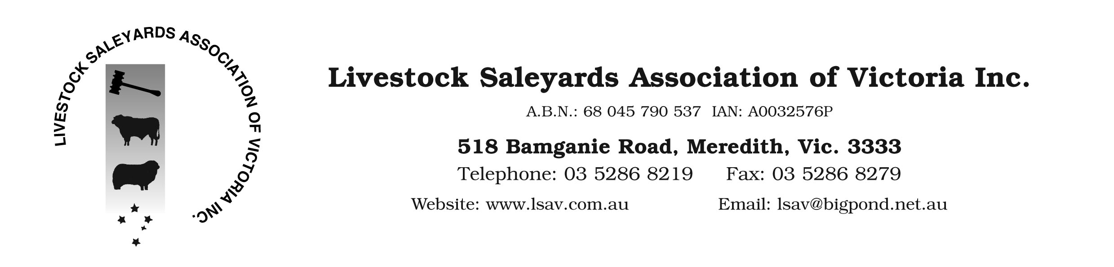

PRESS RELEASE

24 August 2016

ASLA Supports Introduction of Mandatory Sheep RFID in Victoria

Today’s announcement by the Victorian Agriculture Minister regarding compulsory tagging of sheep in Victoria from 1 January 2017 is supported by the Australian Livestock Saleyards Association (ALSA – formerly the Livestock Saleyard Association of Victoria LSAV). Our association has been a long time supporter of a move to mandatory tagging for the sheep industry. This reflects our belief that the current mob based movement does not provide a robust enough system for biosecurity trace back and cannot be resourced efficiently enough in the future to compete with an electronic system. This position is supported by several studies in recent years, eg. Sheep catcher. We also believe that in the medium term the use of electronic sheep RFID tags will provide a strong base for on farm productivity gains and enhanced feedback from processors to the farm.

Our support has been based on adequate funding being made available to provide infrastructure and training for saleyards in advance of any scanning deadline. We will work with government to ensure that our saleyards are supported in this manner and are kitted out and ready for scanning from 1st July 2017. We also believe that the introduction of the system in Victoria will ultimately lead to a national system for the sheep industry. It is common practice with large projects to prototype or release in a smaller controlled environment to test and enhance the system before release to the broader market. Victoria can provide this role before a national release which will minimise unnecessary duplication of effort in the short term.

ALSA will be working with its membership base over the next 12 months to ensure that the necessary equipment, systems and training are available to ensure the Sheep RFID system is introduced as smoothly as possible for all stakeholders in the industry. ALSA has members in Victoria, South Australia and NSW.

Finally, we would like to congratulate Minister Pulford on making this ground breaking decision. This will provide long term benefits for the industry in terms of productivity, biosecurity and export market access.

If you require any further information please contact me (0422 312607).

Rgds

Mr Mark McDonald
Executive Officer, ALSA

