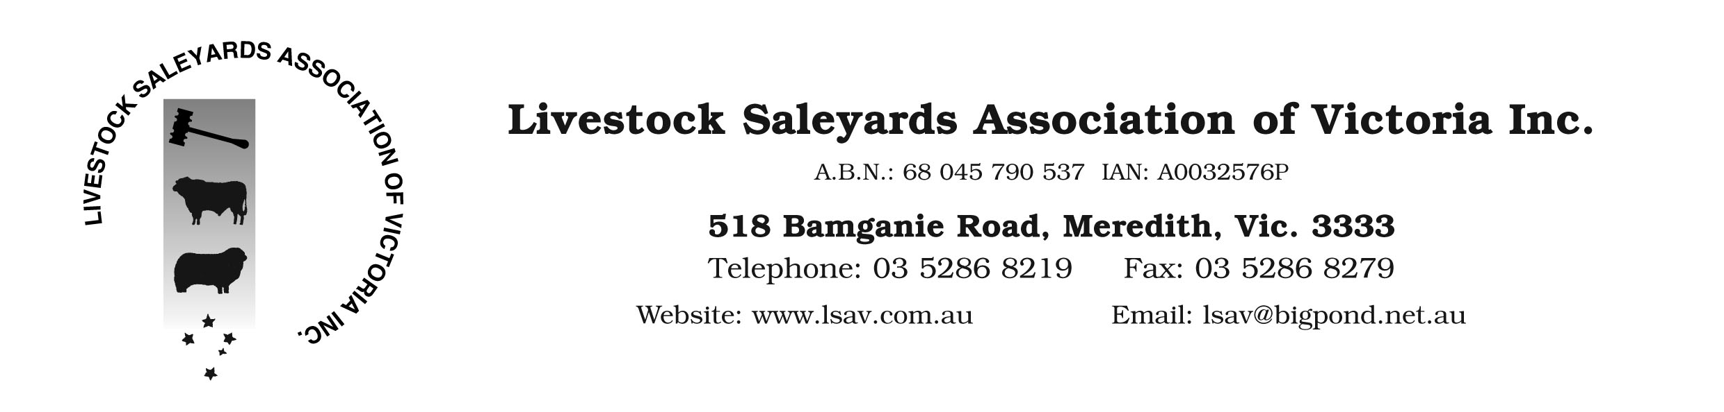

16 November 2015

LSAV Members

NEW OH&S PACKAGE

Dear Members,

I’m writing to advise you that the new OH&S saleyard Package is ready for distribution. This has been created by EQAS with the brief to update this manual to reflect either the new ‘nationally harmonised’ WH&S Act and Regulations or the existing Victorian OH&S Act and the relevant Codes of Practice (whichever is the most onerous). Therefore this package will be applicable on a national basis.

New 2015 Version

There are a number of changes to the 2015 version compared with the 2007 copy. This includes:
- Adding references to Work Health and Safety legislations outside Victoria, including the ‘duty holder’ concept of Person Conducting Business and Undertaking (PCBU), Officer, Worker, etc., so the manual can be readily applied to other jurisdictions across the country.
- Broader approach to the commitment of workplace health and safety in the policy statement.
- Removed the obsolete term of “Responsible Officer”, and created more safety specific positions within an organisation.
- New procedure on accident management including the notifications to relevant authorities and record keeping for injury management.
- New procedure and tools on how to conduct risk assessments for various situations.
- New procedure and tools for manual handling risk assessment.
- New procedure and tools for management of plant safety including improved risk assessment checklist.
- New procedure and tools for working at height and fall prevention management.
- New safety system procedures covering more safety issues such as safe vehicle driving, using PPE, managing fatigue, alcohol and other drugs, emergency response and planning, managing claims and rehabilitation, harassment and bullying, forklift safety, managing noise, traffic management and asbestos management. These new procedures were developed following codes of practices released by Safe Work Australia.
- Improved templates for developing your Safe Work Method Statements (SWMS) and Safe Operating Procedures (SOP)
- A new Emergency Response Plan template that can be easily adapted to each individual workplace.
- A new induction handbook for all workers that summarises all key requirements of the safety system and can be given to workers and used as a training tool. (this covers workers directly employed by the saleyard owner and not 3rd party employees),
- An updated 3rd party user induction pack including trainer and trainee handbooks and training ‘PowerPoint presentation’. The current database will be maintained by LSAV as per the previous arrangements,
Transition

For saleyards that have taken up the 2007 version the following steps will be required to transition this version to the new one:
- Place your order for your new manual to LSAV ASAP
- Receive your copy by postage directly from EQAS
- Review the manual in preparation for the training workshop in February 2016
- Depending on your current level of implementation, you will need to think about:
- Senior management commitment to the update
- Areas that may need customising to specific saleyard situations
- How to engage, consult and involve workers, contractors and 3rd party users

Costs and Distribution

The LSAV executive has set the fee for the new package at $400 + GST. This basically covers the cost of production and distribution as well as training and support. Saleyards taking up the offer will need to provide good resolution versions of their logo to complete the production of their hard copy manual and CD. The fee for non member saleyards is $1500 + GST.

Training and Support

The following training and support options will be available:

- How to use guide with each CD purchase,
- Summer (Feb) workshop session with Greg Francis from EQAS.
- Regional workshops for members taking up the package conducted by LSAV,
- Telephone support from the LSAV Executive Officer.
- Engagement direct with EQAS on a ‘one-on-one’ user pay basis

If you require any further information please contact Mark McDonald.

Rgds
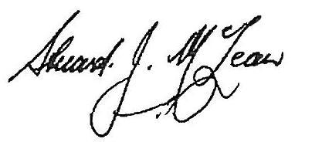
Cr Stuart McLean
Chairman, LSAV

