GUIDE FOR SAFE DESIGN OF LIVESTOCK LOADING RAMPS AND FORCING YARDS

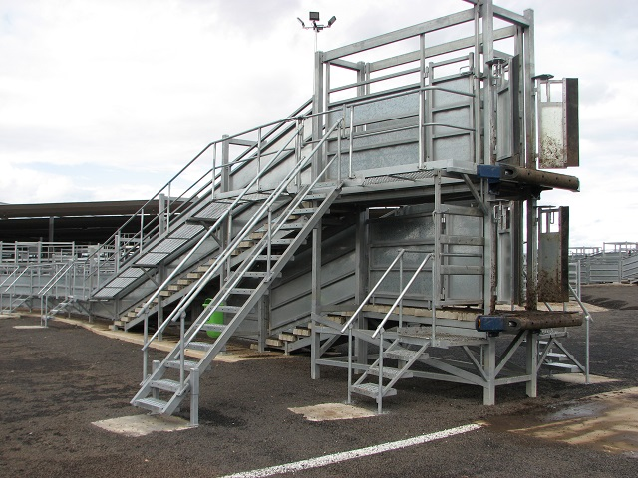

Version: 27 February 2015

Table of Contents
Page
1.0 Introduction 3
2.0 Scope 3
3.0 Health and Safety Obligations 3
4.0 Animal Welfare Obligations 4
5.0 Identifying the Hazards 4
6.0 Assessing and Controlling Risks 4
7.0 Critical Control Points for Livestock Ramps and Forcing Yards 5
8.0 General Design Principles 6
9.0 Suggested Controls to Manage Specific Risks 6
9.1 Critical Control Point 1: Interface between truck and loading ramp 6
9.2 Critical Control Point 2: Exit / entry gate at top of ramp 7
9.3 Critical Control Point 3: Loading / unloading ramp parameters 8
9.4 Critical Control Point 4: Gaining access 10
9.5 Critical Control Point 5: Interface in forcing pen 11
9.6 Critical Control Point 6: Gates striking operator 12
10.0 Suggested Ramps Designs 12
10.1 Single deck and multi-deck ramps 12
10.2 Total number of ramps 12
10.3 Designs for sheep, pigs, lambs, goats and calves 13
10.4 Designs for cattle 13
Appendix A – Designs for sheep, pigs, lambs, goats and calves TBC
Appendix B – Designs for cattle TBC
Appendix C – Glossary of terms TBC
Appendix D – Key contacts TBC
Appendix E – Acknowledgements TBC
Appendix F – Reference Material TBC

GUIDE FOR SAFE DESIGN OF LIVESTOCK LOADING RAMPS AND FORCING YARDS
1.0 INTRODUCTION
This guide provides information on the safe design, construction and operation of livestock loading/unloading ramps and forcing yards. The purpose of the guide is to promote safer workplaces for people in contact with livestock loading facilities and to improve animal welfare outcomes.
The guide is a tool to assist in the assessment of existing facilities and aid in the design of proposed new facilities. It summarises the potential hazards of livestock loading ramps and forcing yards and practical examples of ways to control associated risks for different types of facilities. General principles are identified as well as a series of model ramp designs (ranging from low-cost basic designs for farms to more advanced commercial designs) that adhere to these guidelines.
Legislation requires that safety risks be controlled as far as is reasonable practicable. The guide does not replace any statutory or accreditation requirements that may apply. Examples of other requirements that may apply are at Appendix F.
2.0 Scope
This guide deals with the movement of livestock and the facilities used from the time livestock are drafted into forcing pens, traverse a loading ramp and enter a transport vehicle (or vice versa). Other stages of the livestock supply chain are not included.
Examples of the types of facilities to which these guidelines may apply include farms, feedlots, spelling yards, saleyards, import/export terminals and abattoirs.
Examples of specific elements addressed include races, surfaces, side sheeting, supports, gates, latches, hinges, chains, ladders, steps, platforms, catwalks, bridging, flaps, guards, winches, lighting, signage, vehicle access and management controls.
3.0 HEALTH AND SAFETY OBLIGATIONS
While specific legislation can differ across State and Territory jurisdictions, everyone in the workplace has a work health and safety duty. The main duties of the national Model Work Health and Safety Act are set out in Table 1.
Who | Duties
Person conducting a business or undertaking | A person conducting a business or undertaking must ensure, so far as is reasonably practicable, that workers and other people (i.e. all persons who may be exposed to risks at a livestock loading location) are not exposed to health and safety and welfare risks arising from the business or undertaking.
Designers, manufacturers, suppliers and importers | Designers, manufacturers, suppliers and importers of plant or structures must ensure, so far as is reasonably practicable, the plant or structure is without risks to health and safety. For example, ensuring construction materials used for facilities are fit-for-purpose.
Officers | Officers, such as company directors, have a duty to exercise due diligence to ensure the business or undertaking complies with the Work Health and Safety (WHS) Act and Regulations. This includes taking reasonable steps to ensure the business or undertaking has and uses appropriate resources and processes to eliminate or minimise risks at the workplace.
Workers and others | Workers and other people at the workplace must take reasonable care for their own health and safety, co-operate with reasonable policies, procedures and instructions and not adversely affect other people’s health and safety.

4.0 ANIMAL WELFARE OBLIGATIONS
All persons are subject to particular state and territory laws for the prevention of cruelty to animals including livestock. Additional specific duties also apply to all parties in the livestock supply chain under the Australian Animal Welfare Standards and Guidelines for the Land Transport of Livestock and the Australian Animal Welfare Standards and Guidelines for Saleyards and Depots (proposed).
5.0 Identifying the Hazards
The first step in the risk management process is to identify all hazards. Hazard identification should be done as early as possible in the concept development and design phases. For proposed new infrastructure, this involves identifying issues, practices and situations that could potentially cause harm to people or animals throughout the livestock loading facility’s lifecycle and the reasonably foreseeable hazards associated with each activity.
Hazards usually relate to the plant itself or how and where it is used. Hazards may be identified by conducting workplace inspections and reviewing work procedures in conjunction with this guide.
It is also beneficial to consult with workers, equipment users, manufacturers, importers, suppliers, plant and health and safety specialists and review relevant information, records and incident reports.
6.0 ASSESSING AND CONTROLLING RISKS
A risk assessment involves considering what could happen if someone is exposed to a hazard and the likelihood of it happening. Risk controls must effectively eliminate the risk or, where that is not reasonably practicable, minimise the risk. Elimination is the most effective control measure and must always be considered before anything else.
This guide primarily aims to address hazards in the design phase. While sound livestock handling techniques are essential to reduce the risk from interacting with livestock, ensuring livestock loading facilities are appropriately designed to eliminate or minimise risk is the most effective method and can avoid costly changes after livestock loading facilities are operational.
The risk controls specified in these guidelines have been developed in consultation with industry participants across the animal supply chain. However, these controls are non-exhaustive and innovative approaches to controlling risk is encouraged where required.

7.0 Critical Control Points for Livestock RAMPS and FORCING YARDS
A critical control point is the point in a process where failure to control known hazards can lead to serious harm to people, animals or equipment.
The livestock loading process is relatively common and well-understood. Industry experts agree that there are six critical control points as illustrated in the example cattle ramp and forcing yard at Figure 1.
Addressing these critical control points has the greatest impact in terms of reducing risks and meeting legislative obligations.

INSERT UPDATED DIAGRAM

Figure 1: Critical control points for loading ramps and forcing yards.

8.0 General DESIGN PRINCIPLES
As the volume of livestock throughput and/or frequency of use increases, so do the potential risks and the need to have purpose built equipment that deals with these risks.
Around Australia there are many different types of livestock loading facilities. The following scenarios typically apply:
- Small farms: low volume, infrequent usage.
- Mid-farms / small commercial facilities: medium volume, infrequent usage.
- Large farms / medium commercial facilities: medium volume, frequent usage.
- Annual / special sales: medium-high volume, infrequent usage.
- Large commercial facilities: high volume, high frequency.
Work health and safety laws recognise that what is ‘reasonably practicable’ for different facilities can vary depending upon factors such as frequency of use and exposure, type of stock being handled and environmental conditions. However, there are some general design principles that should be applied to all livestock loading facilities regardless of their size. These include:
Consider the primary aim:
- Separation of people and animals;
- Facilities should minimise safety and welfare risks and promote smooth ‘flow’ of livestock;
Consider the intended use:
- Ramps should be constructed appropriate to the species of stock and vehicles used;
- Ramps should be aligned north-south to avoid loading into the sun;
- Noise and visual distractions should be minimised;
- Adequate overhead lighting should be provided if the facility will be used at night;
- Ramps should be built to enable single operator use and ease of operation (Note: It is advisable that ramps are not operated by a single person. However, where appropriate the ramp design should take into account that this is sometimes unavoidable);
Get the design right:
- Facility operators should consult with facility users to assist in the initial design phase;
- Identified hazards should be addressed through good design in preference to management controls;
- Use non-slip and non-bruising materials throughout;
- Engineer’s information and statutory requirements should be referenced when replacing bolts, cabling and hardware to maintain a safe working load;
Maintain safety standards:
- Facility operators should regularly consult with facility users to assist in the early identification of emerging safety risks;
- Facilities should be clean and in a good state of repair;
- Safe working loads should be displayed on the ramp and any winch / hoist;
- Persons using the facility should be appropriately trained according to their role;
- Signage should display emergency contact details for the facility operator;
- Facility users should report all faults or safety issues to management.

9.0 Suggested controls to manage SPECIFIC risks

9.1 Critical Control Point 1: Interface between truck and loading ramp
# | Hazard | Risks | Controls
1. | Crushing point between rear of trailer and front of ramp. | - Severe injury or death due to entrapment or being struck by vehicle. | - No go zone behind vehicle.  - Reversing alarms on vehicles.
2. | Ramp not securely fixed to the ground. | - Ramp moving backwards or becoming unstable when vehicle backs into it. | - Fixed ramps must have suitable foundations to prevent movement.  - Portable ramps must be securely fixed.  - Mobile ramps should have suitable wheel chocks and anchoring devices to prevent movement.
3. | Ramp not securely fixed or aligned with the vehicle. | - Damage to rear of stock crate.  - Slip, trip, fall Injury to operator.  - Injury to stock due to legs falling between gaps.  - If gap too excessive provides possible escape point for stock.  - Risk to public being struck by escaped animals.  - Operator being struck while retrieving flap. | - Secure structure.  - Solid extensions should be used to cover any gaps between the loading ramp floor and the floor of the vehicle.  - Suitable alignment for truck to ramp.  - Ramp at suitable height for vehicle.  - Ideally, there should be a self-aligning compressible interface with the vehicle – particularly if drivers find it difficult to pull up ‘squarely’.  - Buffer stops on front of ramp in good condition.  - Curved fold down flaps made from non-slip material available to compensate for height variation.  - Flap retrieval mechanism has a chain attached to the ramp in a position where the operator does not need to bend down and can access it from inside the ramp (ADD PHOTO).
4. | Poor vehicle access to loading point. | - Damage to vehicle or ramp.  - Inefficient loading practices causing stress to people and animals.  - Crash risk to vehicles on public roads. | - Access should accommodate appropriate transport vehicles that frequent the site.  - Ideally, access should at least provide for a b-double and larger vehicles such as road trains in areas where the road network allows.  - Vehicular approach to the ramp should have a slight fall backwards to enable vehicles to be rolled into position gently. A line should be painted on the road surface or reflective material fitted to assist this approach.  - Side loading vehicles should be able to approach a ramp on a level surface.  - Ideally, vehicles should not be required to commence reversing on a public roadway (always check local laws).  - Use of loading facilities should not block vehicle traffic flow either within the facility or on a public roadway.  - Entry and exit points for vehicles should minimise traffic hazards.  - Develop a consistent traffic flow plan (e.g. clock-wise only).  - Ensure traffic flow is free from dangerous obstructions such as power lines and trees.
5. | Rough, slippery or steep access from ground level to facility creating slip, trip or fall issue. | - Laceration or fracture injury to operator. | - Provision of suitable access such as walkway or ladder with non- slip surface.

9.2 Critical Control Point 2: Exit/entry gate at top of ramp
# | Hazard | Risks | Controls
1. | No emergency exit /entry gate at top of ramp. | - Inability of operator to exit quickly in an emergency to prevent being struck by an animal. | - Self-closing, inward-opening, non-latching gate at top of ramp for emergency access. The gate should be ideally 500mm wide to prevent stock escaping and open onto a flat area free of obstructions (Figure 2).  - Consider installing a walkway adjacent to vehicle so there is no need to enter to ramp.
2. | No sliding gate at top of ramp. | - Being struck by stock coming back out of vehicle while closing crate door.  - Striking head on sliding gate frame. | - Provision of sliding gate provides safe access to rear of vehicle to close crate door and retrieval of flap (Figure 3).  - Ensures that crate back door pin has been installed to prevent stock falling from truck during transit.  - Gate should be a reasonable size, be at floor level to avoid a tripping hazard and at a suitable height to avoid hitting head  - External walkway to be positioned on the left hand side of the ramp if slide gate fitted

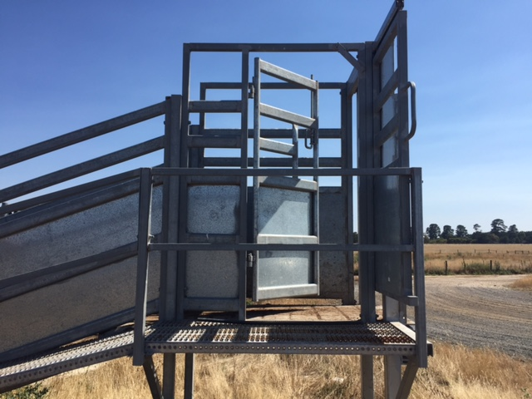 | 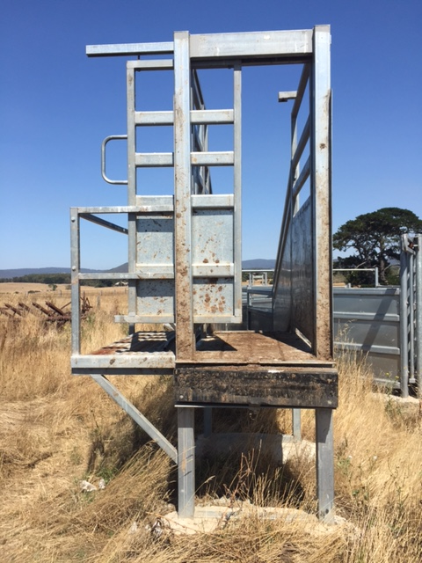
Figure 2: Emergency exit gate. | Figure 3: Slide gate.

9.3 Critical Control Point 3: Loading/unloading ramps
# | Hazard | Risks | Controls
1. | Loading/unloading into a multi-deck crate. | - Slip, trip, fall Injury to livestock or operator. | - Decrease gradient via installing a multi-deck ramp – particularly in high use applications.
2. | Slippery surfaces or protruding objects. | - Slip, trip, fall or impact Injury to livestock or operator. | - Ramps should be constructed with non-slip flooring and non-bruise material.  - Remove any sharp or protruding objects.
3. | Loading ramp too wide allowing stock to baulk or turn around. | - Stock will suffer stress and damage or jam across the ramp.  - Operator may enter the ramp or race in an attempt to move stock. | - Ramp width is determined by the stock being handled, generally the recommended internal width of a load/unload ramp is 800mm for cattle, 900mm for sheep and pigs.  - Dump ramps normally wider.
4. | Overall ramp height inappropriate. | - Poor alignment with crate decks causing steps or gaps.  - Slip, trip, fall Injury to livestock or operator. | - For cattle and horses, ramp height should be 1100mm from the ground for single deck or bottom deck, and 2800mm for the top deck.  - For pigs, lambs, sheep, goats and calves suggested ramp heights are 1100mm from the ground for single deck or bottom deck, and 1400- 1600mm for top deck.
5. | Ramp wall heights inappropriate. | - Too low will allow livestock to exit over the sides.  - Too high will prevent operators exiting in an emergency. | - Ramp wall height should be 1000mm for sheep and 1700mm for cattle.  - Note: Height should be at least 1200mm for goats or an additional top rail could be added.
6. | Ramp incline angle too steep creating difficulty in loading stock. | - Stock will not move up a ramp that is too steep.  - Stock will slip and possibly lay down causing injury. | - Recommended ramp incline angle should not exceed 20 degrees.  - To assist loading and unloading cattle, there should be a flat platform not less than 1500mm in length at the top of the ramp that is level with the deck being unloaded.
7. | Ramp surface too smooth or covered in mud and effluent. | - Stock will slip and possibly lay down causing injury. | - Flooring and surfaces should be designed to maximise grip and minimise slipping and falling. Strategies to improve grip include slats or grooves in the surface.  - Livestock prefer to walk up and down steps rather than inclines.  - For cattle, the surface should be made of non-slip material with either cross cleats, 40-50mm wide spaced at 300mm centres or, if concrete, a suitable cross-grooved pattern of steps to provide good footing when the ramp is wet. Recommended dimensions are 450mm treads and 100mm rises.  - For sheep, ramp steps with 250mm of treads and 50mm rises or cross cleats 25mm wide and high at 200mm centres are recommended.
8. | Lack of infill on the sides of ramp and race walls. | - No or limited infill on ramp side walls cause stock to baulk. There is also the potential for the legs of stock to slide out under the rails causing injury. It also reduces operator exposure preventing entrapment between rails while herding. | - Installation of infill to the inside walls of ramps and races encourages stock to “run” plus reduces the risk of human injury.  - On Under/Over ramps the bottom level walkway should be on the right hand side to aid line of sight into truck to monitor stock movement.  - Railings on ramps and raceways should be of appropriate height, with the gaps sufficiently narrow at the bottom to prevent livestock being caught, slipping through or becoming injured.
9. | Adjustable ramps with faulty safety locks, no operating instructions or designed Safe Working Load displayed are dangerous. | - Unless ramp is locked into a set position it has the potential to fall causing damage to structures and injury to stock and operators.  - Over loading or operating a ramp while loaded with stock poses a significant risk.  - The structural load of the winch is different to its lifting capacity. This can lead to confusion if not clarified. | - Where ramps are adjustable, appropriate safety locking devices should be installed (Figure 4) with clear instructions as to how they are to be used, including that the ramps must not be adjusted with people or stock on them. This information should be available from the engineer’s certification.  - Ramps should not be used if loading capacity is likely to be exceeded. If in doubt consult an engineer.  - Mechanical safety locking devices should be automatic in operation and have vertical increments of no more than 100 mm.  - Mechanical safety locks and lifting equipment should be regularly maintained and operational. Operating instructions and design rated SWL capacity must be clearly displayed.  - Hoists / winches should be attached ensuring that the fixing point can handle the total load.
Note - If a crush is in line with a loading ramp these are the things to consider:
- gates in front of crush to be secure;
- consistent width from the Vet crush through to the ramp to prevent the animal turning; and
- crush operating handles should not impede continuous free access along the side of the crush to enable the operator to control stock.

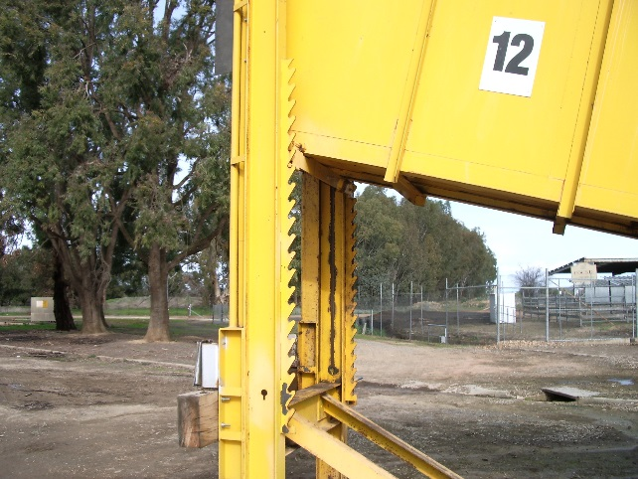 | 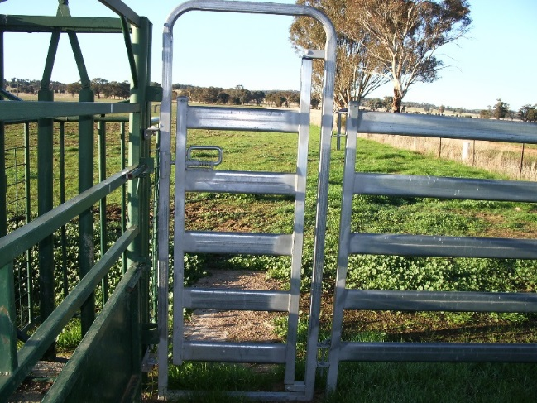
Figure 4: Safety locking device. | Figure 5: Personal access gate.

9.4 Critical Control Point 4: Gaining access
# | Hazard | Risks | Controls
1. | Climbing over rails and gates. | - Potential slip, trip and fall injuries. | - Self-closing, inward-opening, non-latching, 600mm wide, personal access or “man” gates with slam shut catches, strategically located provide safe access to working areas (Figure 5).
2. | Direct exposure to livestock. | - Injury by being struck, kicked or crushed by animal. | - Install externally operated throw gates with slam shut catches (Figure 6a & 6b).  - Provision of a walkway for use by handlers on the outside of the ramp will reduce the need for the handler to enter yard or ramp. It can also facilitate easy stock movement and is essential on sheeted ramps.  - Access into the ramp and hence the vehicle from this walkway is also desirable to facilitate the closure of gates in the loading structure or vehicle.  - Catwalks and walkways should be designed to be continuous without steps to avoid slip and trip hazards and without creating dead ends.  - Catwalks should ideally be positioned on both sides of ramps that can be elevated.  - If fitted on one side only, this should be on the left hand side to facilitate closing of the crate door.  - Extendable catwalks should be fitted where appropriate.  - The walkway should be constructed of a non-slip material, have adequate handrails and kick boards and comply with the Australian Standard – AS1657-2013, 'Fixed platforms, walkways, stairways and ladders - Design, construction and installation'.
3. | Loader climbing onto top or sides of the crate. | - Higher risk of fall if no ladder or platform is provided to assist climbing onto the crate from the loading infrastructure. | - Subject to prevailing state regulations, a ladder or platform can be provided to help the loader to climb to the top of the crate to encourage animals to move through the crate from behind. This is particularly important on under & over ramps servicing trucks with walkways on the top of the crate (these trucks must have compliant walkways with safety rails or safety harnesses available to the operator).
4. | Unauthorised access underneath ramp. | - Injury potential in the event of collapse, falling objects or mechanical devices. | - Only authorised and appropriately trained persons should have access to the loading or unloading facility.  - Consider installing guarding around the base of ramps to prevent unauthorised access.

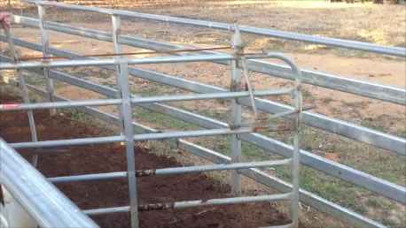 | 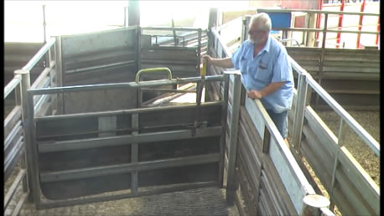
Figure 6a: Externally operated gates on farm. | Figure 6b: Externally operated gates at Pakenham saleyard.
Add Photos of ladder to crate and reference to table.

9.5 Critical Control Point 5: Interface in forcing pen
# | Hazard | Risks | Controls
1. | Slippery surfaces or protruding objects. | - Slip, trip, fall or impact Injury to livestock or operator. | - Forcing pens should be constructed with non-slip flooring and non-bruise material.  - Remove any sharp or protruding objects.
2. | Direct exposure to livestock. | - Injury by being struck or kicked by animal | - Forcing pens should be built to accommodate a pen of stock for the usual size stock vehicles using the facility, plus an additional 20% space (e.g. 1/2 a deck for semis which is usually 2.5m x 7m).  - Forcing pens designed so stock will run with no blind corners.  - Forcing pens should be designed to enable the operator to move and direct stock from the walkway, without having to get in to the pen.
Note 1 – On smaller facilities externally operated slide gates can achieve an effective separation from livestock.
Note 2 - Multiple gates are advantageous to pen livestock and to prevent them from running backwards as they progress through the forcing yard and ramp.
Note 3 - Attempting to move stock for loading directly out of laneways to race/ramp area without holding pens should be avoided.

9.6 Critical Control Point 6: Gates striking operator
# | Hazard | Risks | Controls
1. | Operator being struck by gate. | - Crushing and striking injury due to throw back of gates. | - Throw gates externally operated with slam shut catches.  - Consideration on which side the gate is hinged to minimise risk to the operator.
2. | Attempting to engage chains on gates under pressure. | - Hand or finger laceration. | - Avoid using chain catches or slide bolt type catches on gates as the primary mechanism in high risk areas.  - Note: Chains or slide bolt on gates may be a suitable means of control in low use facilities if installed on a post end, not a gate.
3. | Non captive gate hinges cause gate lift off. | - Damage to stock and operators. | - Ensure gate hinges are designed to prevent lift off.

10.0 SUGGESTED RAMP DESIGNS
Livestock handling facilities can have different loading and unloading requirements depending upon the operation being conducted, intensity of use, type of stock being handled and the type of vehicles using the facility. There is no ‘one size fits all’ solution.
10.1 Single-deck and Multi-deck Ramps
In general, single-deck ramps are adequate for smaller farms and low intensity commercial facilities while multi-deck ramps should be used at saleyards, feedlots, abattoirs and larger farms.
10.2 Unloading Ramps
It is advantageous for some facilities to have specialist unloading ramps, commonly known as ‘dump ramps’. Dump ramps are wider and offer animals an attractive ‘clear run’ out of the vehicle into a holding pen. However, it is dangerous to attempt to load animals with dump ramps and it is important that all facilities have at least one standard loading ramp to enable safe loading of animals that need to be transported away from the facility (e.g. because they were mistakenly unloaded). There are designs available that pair a narrow and a wide ramp side by side to allow maximum flexibility.
10.3 Total Number of Ramps
There are several elements that need to be taken into account when determining the number of ramps required for any given livestock handling facility. These include:
- Peak capacity: There needs to be an adequate number of ramps to efficiently handle the highest volume loading / unloading event that can be reasonable anticipated.
- Capacity constraints: Facility managers should seek to identify, reduce or remove any capacity constraints that otherwise impact on efficient animal flow. Examples of capacity constraints including weighing processes, restricted internal traffic flow or availability of vehicle parking.
- Animal welfare: Smooth and efficient loading improves animal welfare outcomes by decreasing the duration of stressful loading / unloading events.
- Operator Safety: Smooth and efficient loading lessens the likelihood of safety incidents occurring.
- Driver Fatigue: It is important to note that Heavy Vehicle National Law includes a ‘chain of responsibility’ that imposes general and specific liabilities on ‘off-road’ parties such as consignors, schedulers, loaders and executive officers to take reasonable steps to avoid engaging in practices that may contribute to driver fatigue (e.g. unreasonable queueing times). Managers should assess facility infrastructure and practices to identify and address any issues impacting on driver fatigue.
10.4 Designs for Cattle
Appendix A contains model designs for ramps and forcing yards for cattle that have been developed with close reference to the information outlined in this guide.
The model designs include:
- General overhead diagram of ramp and forcing yard layout;
- Basic single-deck ramp;
- Standard single-deck ramp;
- Side-loading single-deck ramp;
- Heavy-duty adjustable ramp;
- Under and over ramp; and
- Under and over dump ramp.
While care has been taken to develop a widely applicable design options, facility operators should take into account their own specific risk profile to ensure that the design choice is the best solution for any particular facility. In some cases, it may be more appropriate to develop a new and unique design using the various individual elements of the model designs as well as innovative approaches to any unusual risks.
10.5 Designs for Sheep, Pigs, Lambs, Goats and Calves
Appendix B contains model designs for ramps and forcing yards for sheep, pigs, lambs, goats and calves that have been developed with close reference to the information outlined in this guide.
The model designs include:
- General overhead diagram of ramp and forcing yard layout;
- Portable ramp;
- Basic single-deck ramp;
- Standard adjustable ramp; and
- Heavy-duty adjustable ramp.
While care has been taken to develop a widely applicable design options, facility operators should take into account their own specific risk profile to ensure that the design choice is the best solution for any particular facility. In some cases, it may be more appropriate to develop a new and unique design using the various individual elements of the model designs as well as innovative approaches to any unusual risks.

appendix C - Glossary of Terms
Catwalk – a walkway or open bridge at least 600mm wide. Usually a raised platform with rails to prevent falls. See Australian Standard 1657-2013 Fixed Platforms, walkways, stairways and ladders – Design, construction and installation.
Control – a control measure, in relation to a risk to health and safety, means a measure to eliminate or minimise the risk. Involves a hierarchy of controls including: elimination; substitution; isolation; engineering; administration; personal protective equipment.
Dump Ramp – A wider ramp designed for high volume unloading.
Duty – a duty imposed on a person to minimise risks to health and safety so far as is reasonably practicable. Duties cannot be transferred. A person may have more than one duty and more than one person can have the same duty.
Emergency Exit Gate – a gate at the top of a ramp used to rapidly exit a ramp onto a platform when there is a risk of being struck by an animal.
Fold Over Flaps – Adjustable curved flaps attached to the top of a ramp designed to eliminate any gap between the truck and ramp. Must be fitted with a chain to assist in retrieval.
Forcing Yard – a holding pen which allows operators to encourage animals up the race or ramp while maintaining segregation between stock and people.
Hazard – means a situation or thing that has the potential to cause harm. This can apply to possible mechanical damage to equipment as well as injury to people and livestock.
Personal Access Gate – A gate conveniently positioned to allow an operator to safety enter or exit the internal structure of livestock facility.
Race - normally a set of parallel panels leading up to the ramp.
Ramp – the stockyard structure used for loading and unloading livestock.
Risk – is the possibility that harm (death, injury or illness) might occur when exposed to a hazard.
Safety Locking Device - failsafe system to hold the ramp in a set position while it is being adjusted.
Slam Shut Catch – part of a latch that is designed to automatically engage when a gate is shut.
Slide Gate – A sliding gate located at the top of the ramp used to prevent animals from re-entering the ramp once loaded into a vehicle and allowing for easy flap retrieval.
Throw gate – An internal gate that includes a slam shut catch that can be operated from an external position.
Winch – a mechanical lifting device used to change the height or incline of a loading ramp.

appendix D - Key Contacts
The following organisations have been involved in the development of this publication:
Organisation | Contact Details
Australian Livestock and Rural Transporters Association | Ph:  E:  W:
Livestock and Rural Transporters Association of Victoria
Livestock and Bulk Carriers Association
Livestock and Rural Transporters Association of Queensland
Livestock and Rural Transporters Association of Western Australia
Livestock and Rural Transporters Association of South Australia
Livestock Transporters Association of Tasmania
Australian Livestock and Marketing Association
Livestock Saleyards Association of Victoria
Victorian Farmers Federation
NSW Farmers Association
Cattle Council of Australia
Safe Work Australia
WorkSafe Victoria
Proway
Australian Pork Limited
Meat and Livestock Australia
Australian Department of Infrastructure and Regional Development
Animal Angels Australia
RSPCA
South East Australian Livestock Exporters Association
Australian Livestock Export Council
Kattle Gear Australia
Thompson Longhorn
National Saleyards Quality Assurance Program standards

appendix E - ACKNOWLEDGEMENTS
This guide was developed by the Australian Livestock and Rural Transporters Association in cooperation with stakeholders within the livestock supply chain, community and State, Territory and Federal Governments.
The extraordinary contributions of the following people and organisations are specifically acknowledged:
- Livestock and Rural Transporters Association of Victoria
- Kevin Simmonds
- Proway
- WorkSafe Victoria
- Safe Work Australia
- Livestock Saleyards Association of Victoria
- Cattle Council of Australia

appendix F – REFERENCE MATERIAL
The guide does not replace any statutory or accreditation requirements that may apply. It should be read in conjunction with:
- Various State/Territory work health and safety laws;
- Various State/Territory prevention of cruelty to animals laws;
- Heavy Vehicle National Law;
- Building Code of Australia;
- Australian Standard AS 1657 2013: Fixed platforms, walkways, stairways and ladders – design, construction and installation;
- Australian Standards for working at heights (various);
- Safe Work Australia guidance for the safe design, manufacture, import and supply of plant;
- Guidance information to identify hazards and risks associated with the interface of people and livestock – Livestock and Rural Transporters Association of Victoria;
- Australian Animal Welfare Standards and Guidelines for Livestock and Saleyards and Depots (proposed);
- Australian Animal Welfare Standards for Land Transport of Livestock;
- TruckCare; and
- National Saleyards Quality Assurance Program standards.

